20MCA134- ADVANCED DATABASE MANAGEMENT SYSTEM LAB Dept. of Computer Applications

|  |
| --- |
| **Name: Vishnu Sadasivan**  **Roll No: 52**  **Batch: MCA B**  **Date:10-06-2022** |

**ADVANCED DATABASE MANAGEMENT SYSTEM LAB**

**Experiment No.: 10**

**Aim**

Create a student table with fields id,name,subject1,subject2,subject3 and total,percentage. For each entry of row, update total marks and percentage using triggers in SQL

**Procedure**

1. Creating table

CREATE TABLE STUDENTINFOR (ID INT(20) PRIMARY KEY , NAME

VARCHAR(20) NOT NULL, SUBJ1 INT,SUBJ2 INT,SUBJ3 INT,TOTAL

INT(30),PERCENTAGE FLOAT );

1. Create Trigger on studentinfor

CREATE TRIGGER MARKCHANGE BEFORE INSERT ON STUDENTINFOR FOR EACH ROW SET new.total=new.SUBJ1+new.SUBJ2+new.SUBJ3, new.percentage=new.total /300 * 100 ;

1. Inserting values to studentinfor

insert into studentinfor(id,name,sub1,sub2,sub3)values(1002,"ram",88,99,54);

insert into studentinfor(id,name,sub1,sub2,sub3)values(1004,"john",66,79,54);

insert into studentinfor(id,name,sub1,sub2,sub3)values(1006,"thomas",38,79,94);

Amal Jyothi College of Engineering, Kanjirappally

20MCA134- ADVANCED DATABASE MANAGEMENT SYSTEM LAB Dept. of Computer Applications

1. Studentinfor Table

SELECT *FROM STUDENTINFOR;

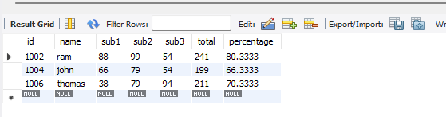

Amal Jyothi College of Engineering, Kanjirappally